User manual
On
Restful Web Services

Document Revision and Approval History

Title: User Manual Web Services

ID :

Effective: 06-Jun-2014
Edition No. | Release Date | Author’s Name | Software Version | Reason for Change / Description of Changes
1 | 06/06/2014 | Praneeth | Jersey 1.17
2 | 03/11/2014 | Praneeth | Jersey 1.17
3 | 24/02/2015 | Manish

About:
This tutorial is intended to provide you hands-on understanding of using web services to stream vehicle sensor information coming from the device / gateway via GPRS [Cellular] network into a NoSQL database deployed on the cloud.
You will be creating a RESTful web service using Java based Jersey reference implementation in an already provided Eclipse development environment on a virtual machine that you have connected to. The web service will have logic to store the information in MongoDB using the same mechanism that you have used in the previous MongoDB related tutorial. You will deploy this web service on your local Tomcat server that is available within the Eclipse IDE and use a REST Client to send JSON formatted data from your local machine to this web service on the cloud.
Since the virtual machine that you are using is already available on the cloud and has a static / public IP address, the web server [tomcat] can directly be accessed from outside to call these web services.
Table of Contents

- Objective
- End to End IOT flow
- Practical flow
- Restful web services introduction
- Jersey Annotations
- Load project on server
- HTTP GET METHOD EXAMPLE 1:
- HTTP GET METHOD EXAMPLE 2 :
- HTTP GET METHOD Exercise:
- HTTP POST METHOD EXAMPLE :
- HTTP POST METHOD Exercise:
- Differences between HTTP GET and HTTP POST:

- Objective:
- Hands-on experience on Restful Web Services
- Understand implementation of Http Get and Post methods for REST Web Services

- End-End IOT Flow:
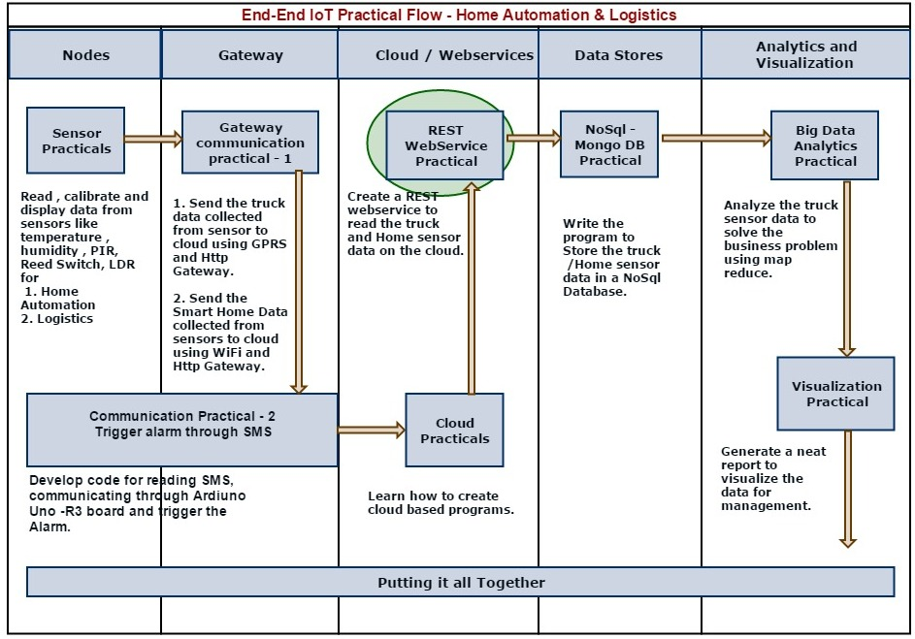

- Practical Flow Diagram:

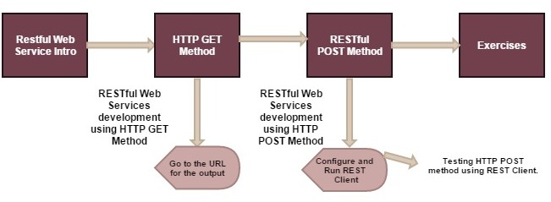

- RESTful Web Services Introduction:

REST (REpresentational State Transfer):
- REST is an architectural style which is based on web-standards and the HTTP protocol. REST was first described by Roy Fielding in 2000.
- In REST based architecture everything is a resource. A resource is accessed via a common interface based on the HTTP standard methods.
- REST allows that resources have different representations, e.g., text, XML, JSON etc.

JAX-RS (Java API for RESTful Web Services):
JAX-RS is a Java programming language API that provides support for creating web services according to the Representational State Transfer (REST) architectural pattern.
JAX-RS uses annotations, introduced in Java SE 5, to simplify the development and deployment of web service clients and endpoints.

Implementations of JAX-RS
Implementations of JAX-RS include:
- Apache CXF, an open source Web service framework.
- Jersey, the reference implementation from Sun (now Oracle).
- RESTeasy, JBoss's implementation.
- Restlet, created by Jerome Louvel, a pioneer in REST frameworks.
- Apache Wink, Apache Software Foundation Incubator project, the server module implements JAX-RS. Etc....
We have used Jersey (https://jersey.java.net/download.html) Implementation to develop our sample Application.

- Jersey Annotations
JAX-RS provides some annotations to aid in mapping a resource class (a POJO) as a web resource. The annotations include:

Annotation | Description
@PATH(your path) | Sets the path to base URL + /your_path. The base URL is based on your application name, the servlet and the URL pattern from the web.xml configuration file.
@POST | Indicates that the following method will answer to an HTTP POST request.
@GET | Indicates that the following method will answer to an HTTP GET request.
@Produces(MediaType.TEXT_PLAIN[, more-types]) | @Produces defines which MIME type is delivered by a method annotated with  @GET. In the example text ("text/plain") is produced. Other examples  would be "application/xml" or "application/json".
@Consumes(type[, more-types]) | @Consumes defines which MIME type is consumed by this method.
@PathParam | Used to inject values from the URL into a method parameter.  This way you inject, for example, the ID of a resource into the method to get the  Correct object.

REST Practical:

- Load Project on server :

Before starting the practical, you should have connected to your virtual machine on the AWS cloud. Please ask the trainer in case you don't have the details of the virtual machine or having problem with connecting to it through remote desktop.

Follow below steps to run sample project on Eclipse IDE.

- Double click on Eclipse IDE which is there on virtual machine desktop and then open “WebServicesTraining” project that contains below structure.
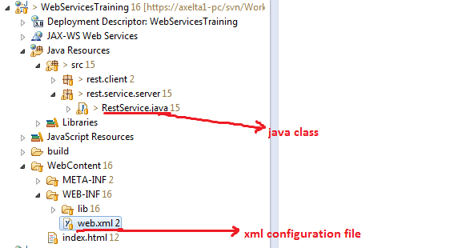
Screen 1

- Then right click on above project and select Run as → Run on server

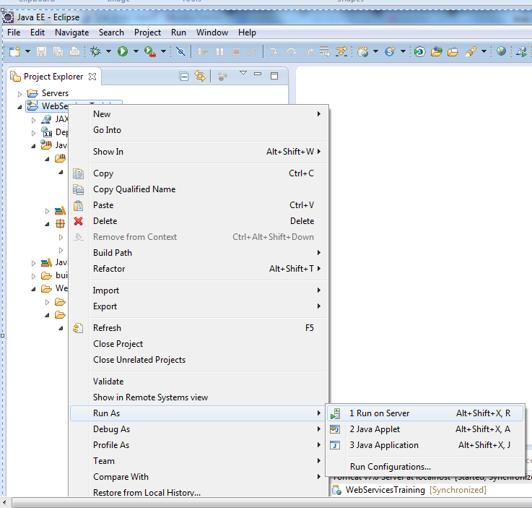
Screen 2

Select Run on Server, click on Finish button in the new window that opens up. You will see an indication that the project loaded on server. Your project is now deployed on the inbuilt tomcat server of Eclipse and so you can access the project from the browser. Tomcat server is an container that supports http protocol. Check out more on Tomcat web servers here

If you get below screen shot as the output then the project has uploaded on tomcat server successfully.

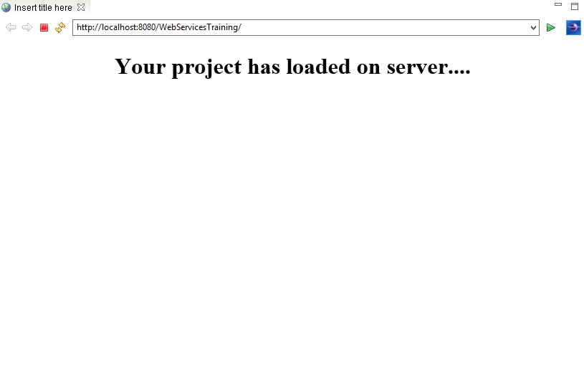
Screen 3

- HTTP GET METHOD EXAMPLE 1:

- Here we will write a simple http get method and understand how the annotations and redirections work based on http method called as well as url

- On the local machine web browser type URL as
http://localhost:8080/WebServicesTraining/rest/service/web and run it.

Note: Since this is being run from local browser you are using localhost as the host

Look at below screen shot for reference.

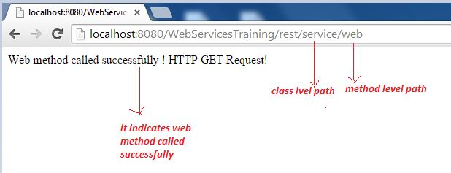

Screen 4

URL Details:
URL: http://localhost:8080/WebServicesTraining/rest/service/web

Http – protocol
localhost – host where the server is running
8080 - Server port number (default used for http protocol)
WebServicesTraining – project name
rest – url pattern, configured in web.xml (explained below)
service – Class level Path variable (explained below)
web – method level path

Web.xml file is present at WebServicesTraining → Web Content→WEB-INF folder.

This file has all the configuration details of the web server. The scope of training does not permit us to go in much details of the Tomcat configuration and relevant aspects have been explained below. More detailed explanation on the web.xml is available here on Tomcat site

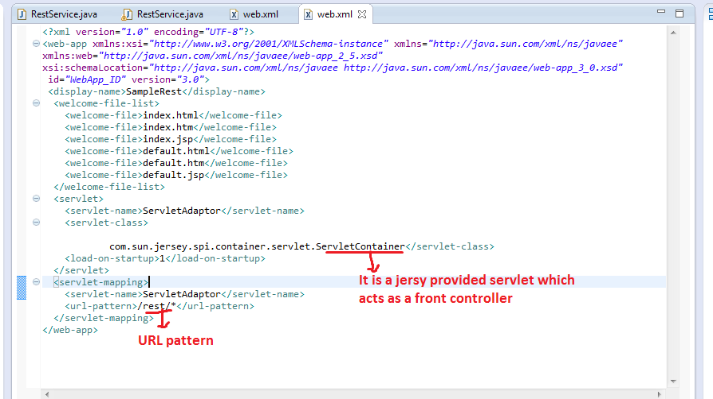

Screen 5

- In above web.xml file ServletContainer is a java class and is responsible for controlling the whole application. By default the application control is given to this container or its derived classes when a call comes to the url. A servlet is how any web server exposes its http functionality.
- Application behaviour and flow: First the application reads the URL from the browser and checks the URL pattern that is configured in web.xml with the browser URL. If it matches (in our case “rest”) then it looks for the class level path that is given in our service class as @Path followed by method level path. More about this class level path below.

- Now open RestService.java class, check the below screen to find the RestService.java class location.

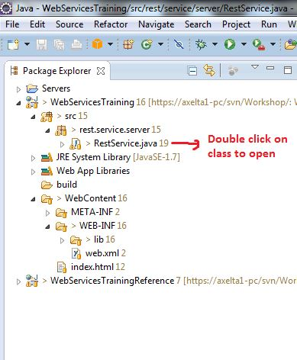
Screen 6

Code inside RestService.java Class:

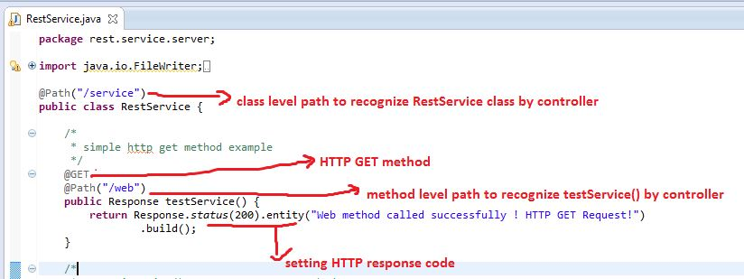
Screen 7
RestService.java is the server side java class that can handle the all web requests. By default this class is called when the web container finds /rest/ pattern in the url as was explained above.
- @Path (“/”) annotation is used to recognize particular service class or method by the controller.
- In our case we are calling URL as http://IPAddress:8080/WebServicesTraining/rest/service/web, here “service” is matching with @Path(“service”) in RestService class so controller will call RestService.java class among the all classes.
- Now ensure that controller recognizes particular method. For this we are passing web on the URL after the service (http://IPAddress:8080/WebServicesTraining/rest/service/web) it matches with @Path(“/web”) and calls the particular method.
- Before testService() method we are using @GET annotation, that means this method can be responded to only HTTP GET request.

To summarize, the web container [tomcat in our case] first gets a web request, it parses the request and the url pattern based on the configuration provided in the web.xml
Based on the pattern defined, it passes control to the RestService.java class where we have more granular handling of the different pieces of the service request based on the url path directory structure and the http method called.

Since we use annotations for handling different web requests and method calls, programming for it becomes very intuitive to handle

- HTTP GET METHOD EXAMPLE 2 :

- Here we will get a list of devices from MongoDB. Method name is devicesList and http method is "Get"
- Run the below URL on the browser
http://localhost:8080/WebServicesTraining/rest/service/devicesList
- You will be see output as mentioned in below screen shot. This is a list of JSON objects that have been returned as an JSON array by the web service method "deviceList" using http "Get"

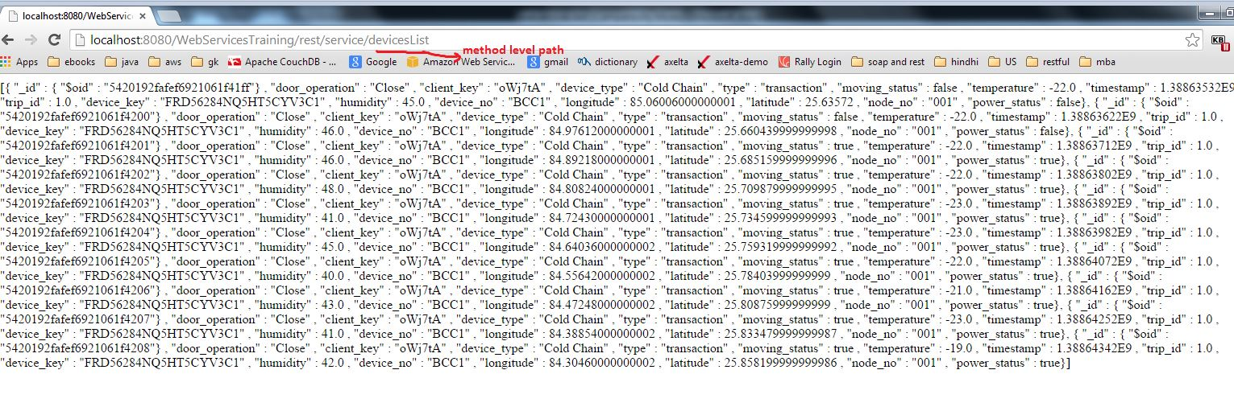
Screen 8

Code Snippet

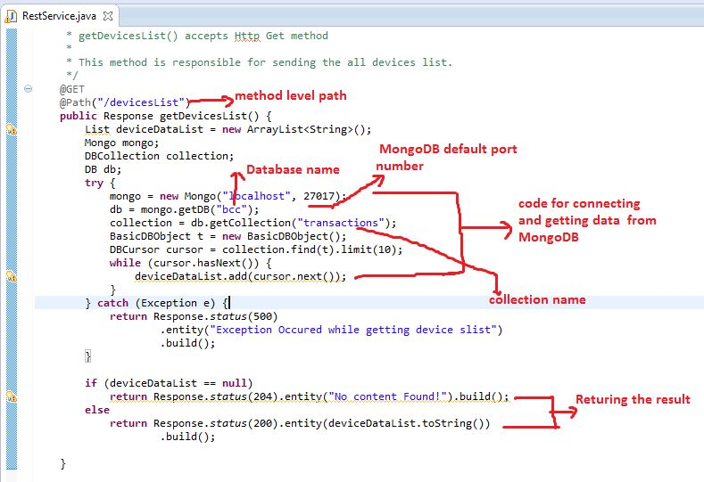
Screen 9

Explanation:
- URL: http://localhost:8080/WebServicesTraining/rest/service/devicesList
- As we are passing devicesList in the URL, getDevicesList() method will be called because we used @Path(“/deviceList”) before the getDeviceslist() method. As shown in the code snippet above
- getDevicesList() method will be HTTP GET request, this method responsible for getting the device data from MongoDB and return to client.
- Java code for connecting to MongoDB. Earlier you had used command line interface for MongoDB access. Following is the Java API that is provided by MongoDB for accessing and managing it

Mongo mongo = new Mongo("localhost", 27017); // Make connection
DB db = mongo.getDB("bcc");
DBCollection collection = db.getCollection("transactions");

Note:
- 27017 is the default TCP port number for MongoDB
- bcc is the mongo database name
- transactions is the collection name where device data has stored
- Code for reading data from mongoDB

BasicDBObject t = new BasicDBObject();
DBCursor cursor = collection.find(t).limit(10);
while (cursor.hasNext()){
deviceDataList.add(cursor.next());
}

Note:
- BasicDBObject class object is useful to pass where conditions
- Collection.find() is for to perform lookup operation on MongoDb, here we are getting only top 10 records
- Cursor.hasNext() returns boolean, if it finds next element returns true otherwise false
- cursor.next() is for the read the data from cursor.

- HTTP GET METHOD Exercise: Get specific device by passing a device ID

- Here, we will see how parameters can be sent to the web service methods to get information based on those parameters.
- You need to program for this in same project as was used above.

Copy the getDevicesList method and make following changes
// change the method to
public Response getDeviceData(@PathParam("deviceId") String deviceId) {

// change the annotation to
@Path("deviceNo/{deviceId}")

// Add the following line to the basic DB object
t.put("device_no", deviceId);

- Double click on following file to get updated file after above changes. It can be directly copied and pasted on the RestService.java file in Eclipse
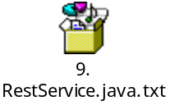
- After that call below URL from the browser http://localhost:8080/WebServicesTraining/rest/service/deviceNo/BCC1
- In the above URL deviceNo is the method level path @Path(“/deviceNo”)
- BCC1 is the device number, it means we will get the data where device number is BCC1
- See the below screen shot for the output

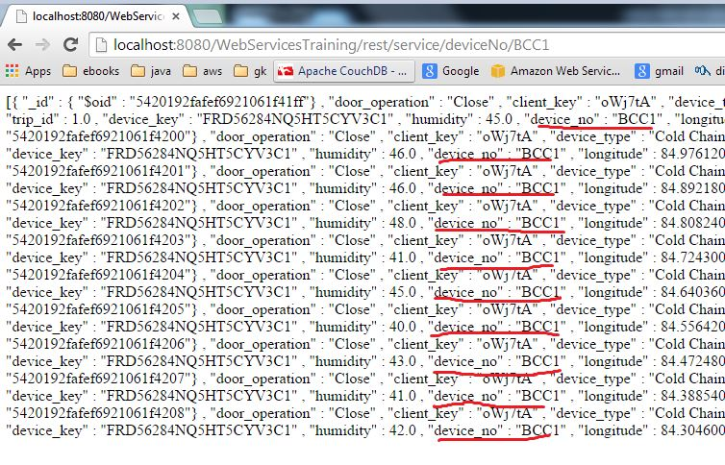
Screen 10

    - Differences between HTTP GET and HTTP POST:
HTTP GET:
- GET is less secure compared to POST because data sent as part of the URL. So it's saved in browser history and server logs in plain text.

- GET does not contain body, data is passed through HTTP Headers

- Since form data in the URL and URL length are restricted, so we can pass limited data.
HTTP POST:
- POST is a safer than GET because the parameters are not stored in browser history or in web server logs.

- Data passes through HTTP Body so no restriction on form data length

    - HTTP POST METHOD EXAMPLE :
Check the below method which is present in RestService class
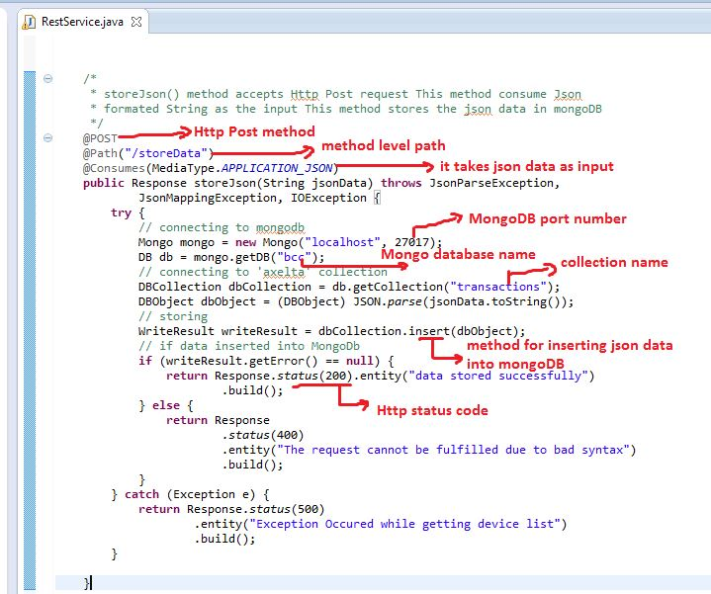
Screen 11

- @POST annotation is to allow the request type as HTTP POST.
- @Consumes (MediaType.APPLICATON_JSON) annotation describes type of data being accepted by the method.
- Above method is accepting the Json string as the input, then we added timestamp to the json object and storing it into the file.
- The standard Http method used by browser when a URL is called is a "GET" method. Therefore for HTTP POST method we will use Advanced REST client app from the chrome web store.
- REST client helps web developers to create and test custom http requests.

Advanced REST Client:

- Use the below url to install and launch the Advanced rest client app from the Google chrome browser on your local machine.
https://chrome.google.com/webstore/detail/advanced-rest-client/hgmloofddffdnphfgcellkdfbfbjeloo

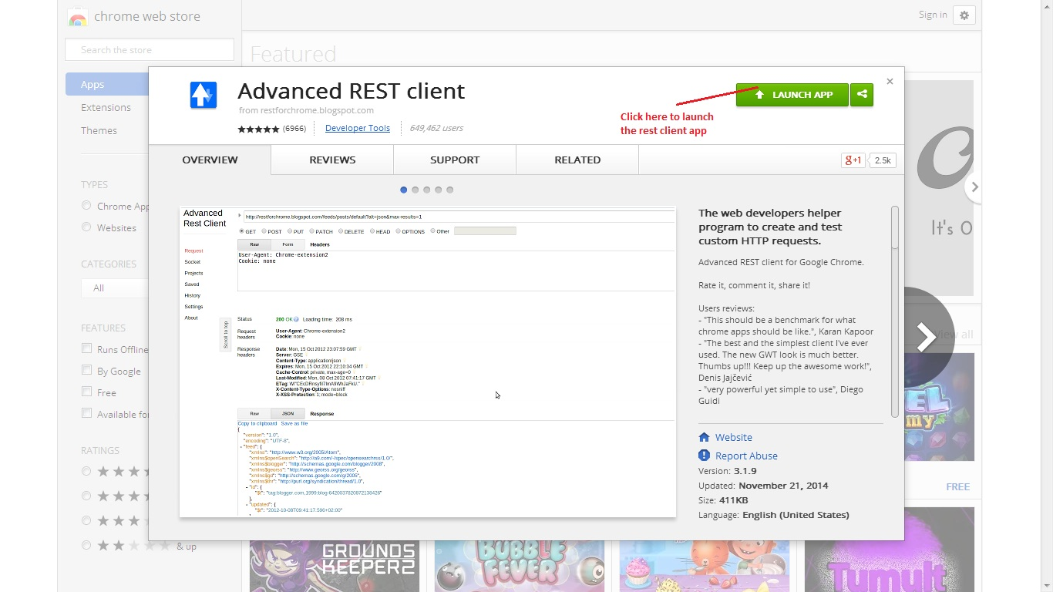

Screen 12

- Click “Launch App” to initialize and get the advanced REST client app running

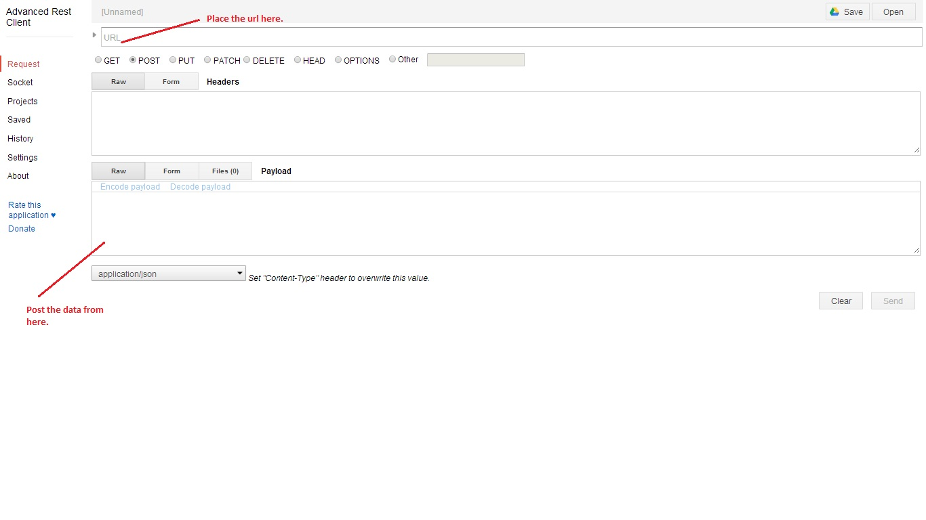
Screen 13

- Copy the below url and paste it into url text box.
http://IPAddress:8080/WebServicesTraining/rest/service/storeData
IPAddress: Provide your virtual machine IP address

- Click the “Post” radio button.
- Copy the below text and paste it into payload text box.

- 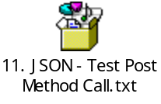
{
"device_no": "Test089",
"door_operation": "Close",
"client_key": "oWj7tA",
"device_type": "Cold Chain",
"type":"transaction",
"moving_status": false,
"temperature": 23,
"device_key": "FRD56284NQ5HT5CYV3C1",
"humidity":45.0,
"longitude":85.06006000000001,
"trip_id" : 1,
"latitude":25.63572,
"node_no":"001",
"power_status": false
}

- Set the "Content-Type" as “application/json”.

- Click the “Send” button to post the data.

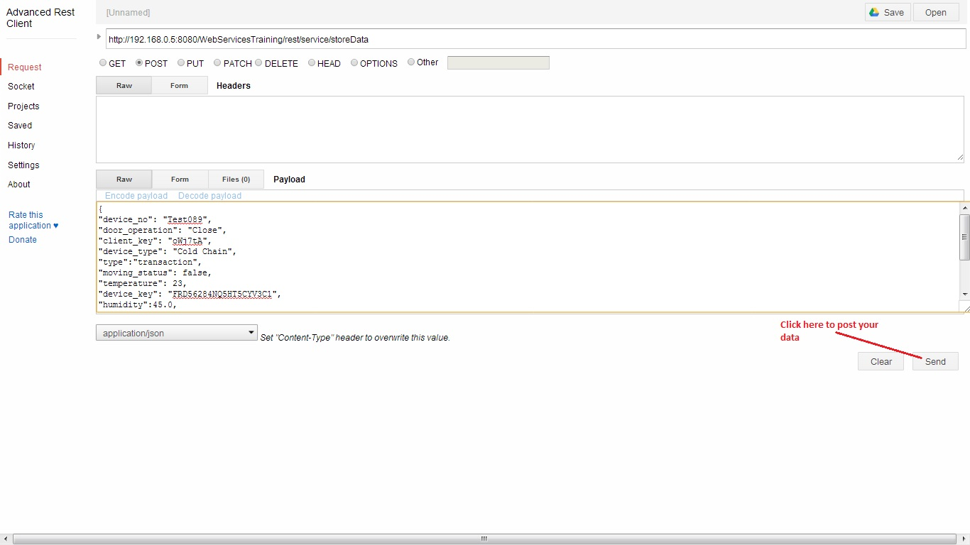
Screen 14

- Below screen shot shows the response of the data posted.

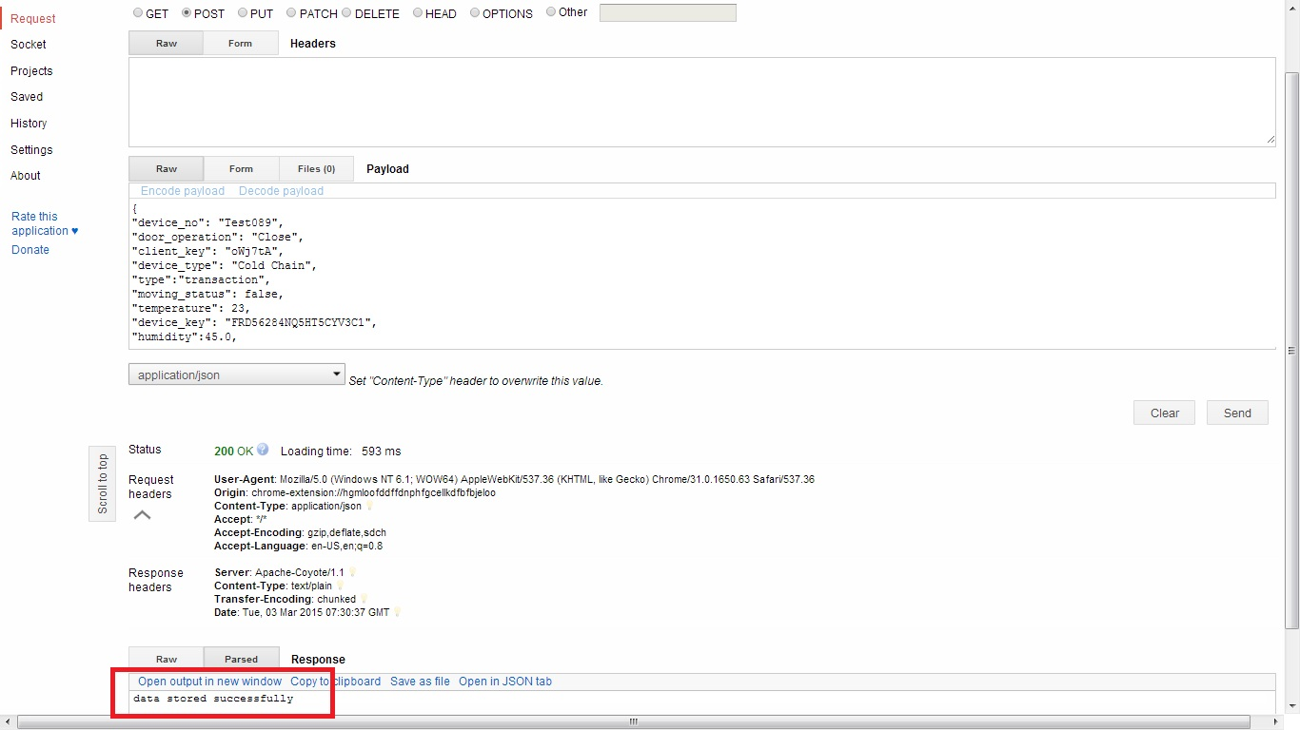

Screen 15

- To check whether data has stored in mongo Db, run the below URL
http://IPAddress:8080/WebServicesTraining/rest/service/deviceNo/Test089

IPAddress: You can either use "localhost" as the IPAddress or provide your VM's IP address. If you use "localhost" make sure that you run it on the local browser on you VM

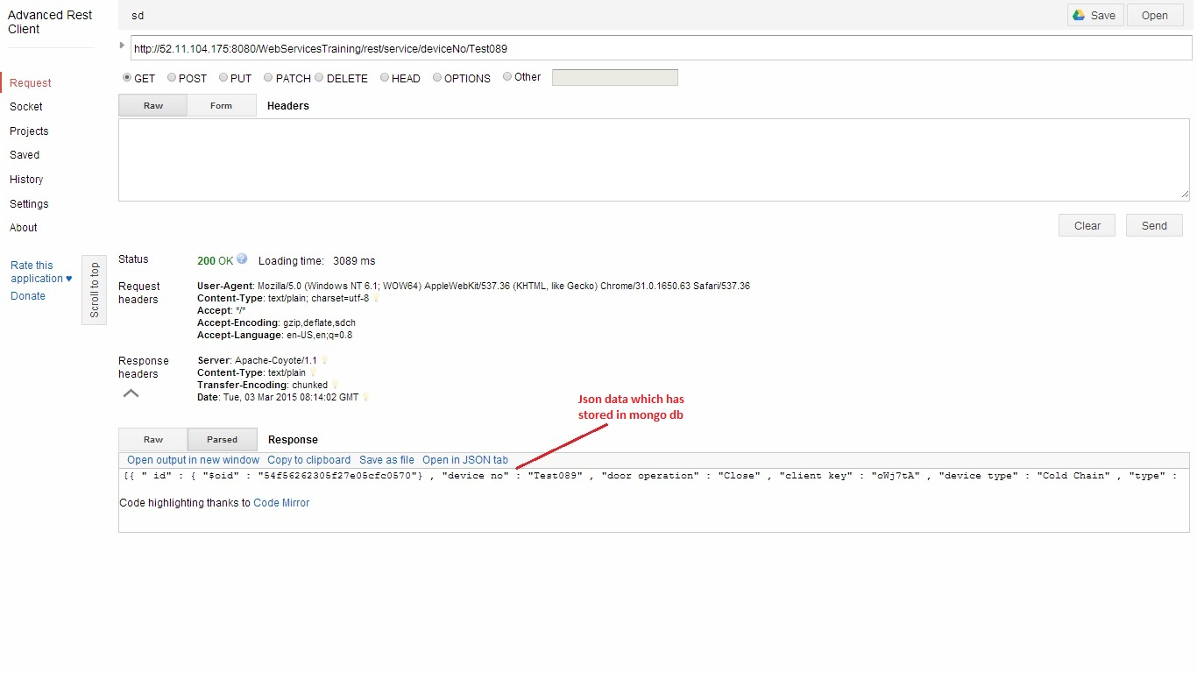

Screen 16

11. Exercise for Post Method

- SAMPLE CODE SNIPPET FOR HTTP POST METHOD :
- In this exercise we pass the latitude and longitude from the rest client and call the Google API to get the location by passing latitude and longitude.

- Place the attached function in the RestService.java class under WebServicesTraining project and save it. Use either of the two below
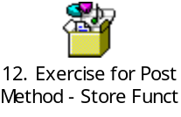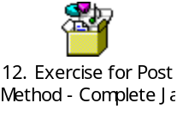
Function Complete Java Class

- Above method takes JSON String as input and it produces response as the JSON Object.
- Open the Advanced REST client and copy the below url and paste it into url text box.
http://IPAddress:8080/WebServicesTraining/rest/service/store
IPAddress: provide your IP address.
- Click the “Post” check box.

- Copy the below text and paste it into payload text box. 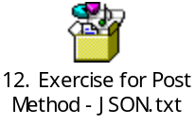
{
"device_no": "XYZ001",
"DOOR": "OPEN",
"device_type": "Cold Chain",
"HUM":"33.01",
"POWER": "OFF",
"device_key": "TV41XB6I443UW3YCV8DZ",
"PIR":"NO.",
"Longitude": "78.042155",
"Latitude": "27.175015",
"trip_id": 1,
"node_no":"001",
"LDR": "61.04",
"Temp": "28.01"
}
- Set the "Content-Type" as “application/json”.
- Click the “Send” button to post the data.
- To check whether data has stored in mongo Db or not, run the below url
http://IPAddress:8080/WebServicesTraining/rest/service/deviceNo/XYZ001
IPAddress: provide your IP address.
- You will see that the location has also been stored in the JSON object in MongoDB. This is an example of a web service calling another web service [Google Maps API]

